**What is Node.js?**

* Node.js is an open source server environment
* Node.js is free
* Node.js runs on various platforms (Windows, Linux, Unix, Mac OS X, etc.)
* Node.js uses JavaScript on the server

**Why?**

**Node**.**js** is a platform built on Chrome's **JavaScript** runtime for easily building fast and scalable network applications. **Node**.**js** uses an event-driven, non-blocking I/O model that makes it lightweight and efficient, perfect for data-intensive real-time applications that run across distributed devices.

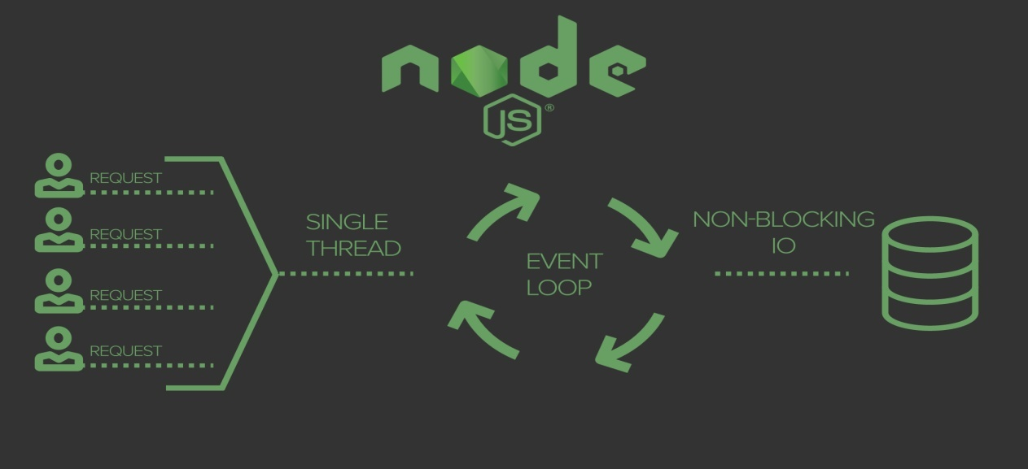

**Installing:**

1. Go to cmd mode from the project folder and type: **node –v** to check the version and if node is installed already.
2. If not, then go to node website and install nodejs from official website.
3. Then go to the project directory and open terminal, type: **npm init**
4. If you don’t want to change the options, then just keep pressing ENTER through all the options.
5. Afterwards, a **package.json** file will be created in the project folder.
6. Now there are various project packages which you might want to install to your project, for that go to [www.npmjs.com/package/mongoose](http://www.npmjs.com/package/mongoose) or express or express-handlebar or body-parser and check their latest versions.
7. Now in the terminal, type: **npm i –s express@VERSION mongoose@VERSION express-handlerbars@VERSION**